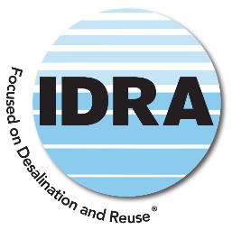
International Desalination and Reuse Association

D. K.C. CHANNABASAPPA MEMORIAL PhD SCHOLARSHIP 2026-2027
APPLICATION FORM & REQUIREMENTS

Given Name Middle Name Family Name
Mailing Address
Nationality Date of Birth Place of Birth

Gender: Male Female | Insert Photo Here:
PRESENT STATUS:
School or Organization:
University to which you seek admission:
The term and year for which this scholarship is requested:
Other source(s) of funding:
Educational Background:
Professional Experience:
Date: Signature

Additional Application Package Requirements:
Please submit the following items with your application in the specified order:
- Submission of Completed Application Form and high-resolution headshot photo - form attached herewith.
- A statement of purpose, detailing your planned career in desalination or water reuse (up to 1,000 words).
- Proof of acceptance to a doctoral program at an accredited university- with a focus on desalination or water reuse solutions.
- Official statement on faculty letterhead from your professor detailing the nature and scope of your research assignment.
- Provide evidence of alternative sources of funding, if applicable, to support the completion of your PhD.
- Submission of (4) Four Letters of Recommendation, with a stipulation that at least one must be provided by an active member of IDRA.
- Submission of both undergraduate and graduate transcripts, including details of your grade point average or class rank. If these documents are not in English, an official translation must be attached.

Kindly submit your entire application package to the International Desalination Reuse Association at easg@idrawater.org and info@idrawater.org

- Deadline for submitting the applications: June 1, 2026.
- Announcement of the final scholarship recipient: July 31, 2026.

